9-MORTALITY

The purpose of this module is to calculate the mortality, pruning, and turnover rates of plant parts (foliage, fine roots, branches, sapwood, heartwood, heartrot, and coarse roots) associated with normal growth processes. The rate that is calculated depends on the layer and the plant part being considered. These variables are used by the GROWTH and DECOMPOSE modules to adjust the live mass of parts or to calculate inputs to dead pools. Dead inputs associated with either harvest or fire are calculated by the HARVEST, PERSCRIBED FIRE or WILDFIRE modules.

During the course of normal growth, the mortality of sapwood, heartwood, and heart-rot occurs when a tree dies. In contrast, the mortality of foliage, fine roots, branches, and coarse roots occurs when a tree dies or when parts are pruned. That is, when the sapwood, heartwood, and heartrot of tree dies, we assume that all the associated plant parts will also die. There is, however, some mortality of these non-bole plant parts even when a tree does not die caused by normal pruning and replacement.

The parameters required by this function are stored in the Mort.prm file.

TreeMort Function

This function determines the rate upper and lower trees die (Figure 9-1). The rate of tree mortality is dependent upon the age of a layer in a cohort. Trees are divided into those capable of expanding horizontally, and those that can not. If the time a species has occupied cohort (TimeThere) is less than the age required for trees to reach its maximum horizontal extent (TimeClose), then mortality rates are dependent on the amount of light absorbed in a cohort. This mimics the effects of density dependent thinning. If the time a species occupies a cohort is greater than TimeClose, then tree mortality is influenced by the maximum age a tree species can attain. This mimics the effects of density independent mortality.

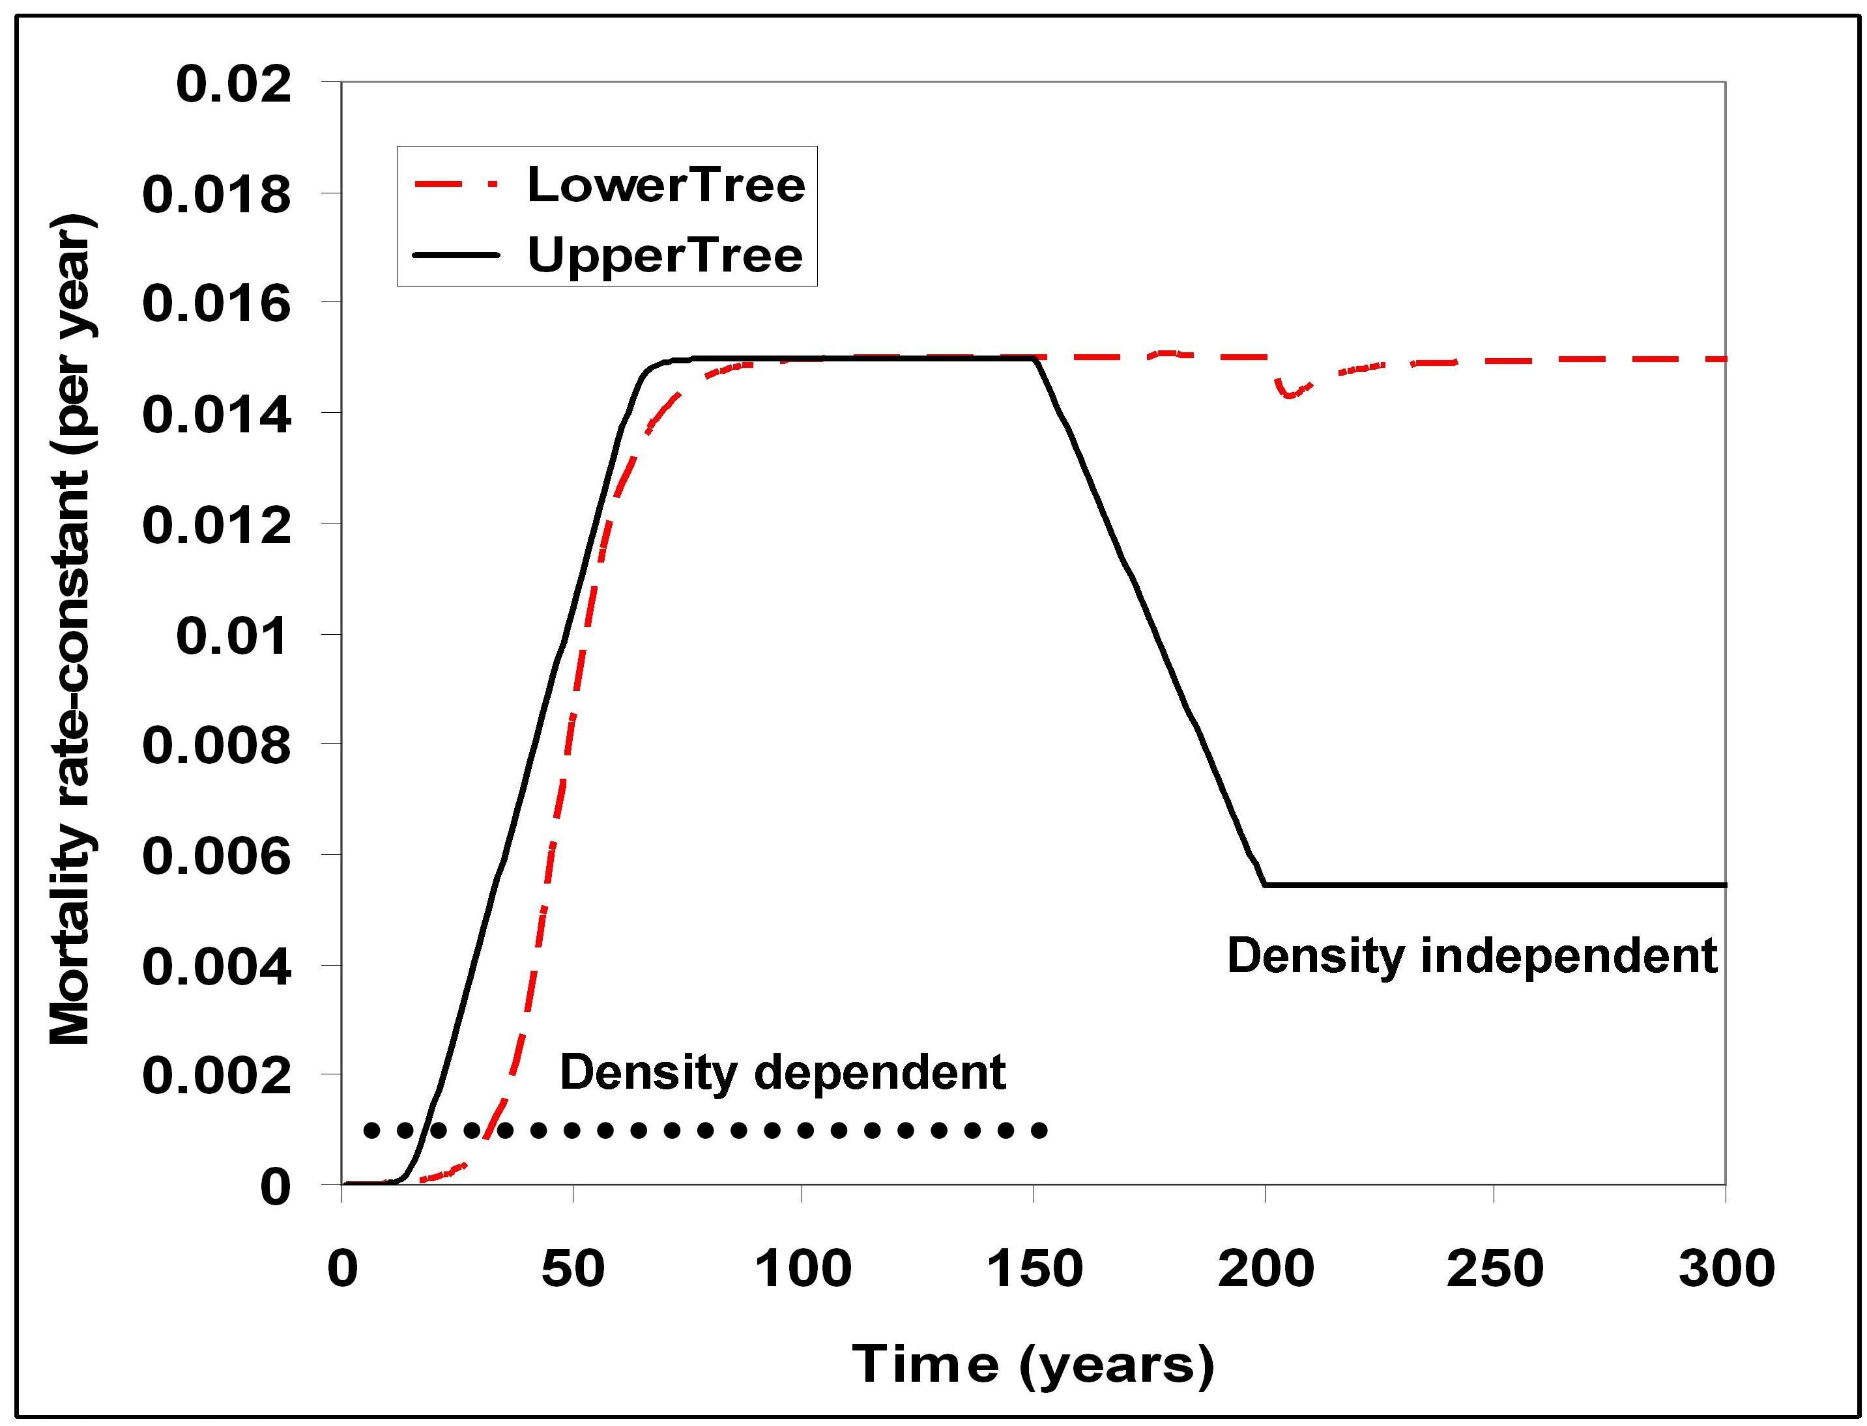

Figure 9-1. Changes in mortality rate-constant predicted over time in the LANDCARB model. Upper trees establish in a pulse, whereas lower trees occur in a wide range of ages.

Since upper trees establish in a pulse and lower trees establish gradually their age structure differs and this influences how mortality changes once TimeClose is reached. The transition between these different mortality rates for upper trees is controlled by the age-class structure of a tree layer in a cohort. Since not upper trees will reach their maximum horizontal extent at the exact same age, the transition is also modified by a probability describing this variation in timing from tree to tree. For upper trees the age-class structure and the probability trees reach their maximum horizontal extent are combined to produce a joint probability distribution that is used to weight the relative contribution of density dependent and independent forms of mortality. For lower trees, the gradual establishment of trees results in an all-aged structure. This means that in old stands that mortality is an average of both density dependent and density independent rates.

A major assumption used to calculate density dependent mortality rates is that as the amount of light absorbed by the stand increases, the mortality rate for trees increases. The amount of light absorbed is taken from the GROWTH module. When TimeThere is less than TimeClose:

LayerMortRateDensityDependent=MortMax*(LightAbsorbed/MaxLightAbsorb)

where LayerMortRateDensityDependent is the rate trees die due to density dependent causes, LightAbsorbed is the amount of light absorbed by the layer, and MaxLightAbsorb is the maximum amount of light that can be absorbed by the tree layer. The later two variables are calculated by the GROWTH module. This function increases mortality as a positive function of the total amount of light removed, mimicking the phase of self thinning during the middle stages of stand development.

For upper trees when TimeThere is greater than or equal to TimeClose, then the tree mortality rate is:

TreeMortRateDensityIndependent= ExtRate

As defined in the DIEOUT module.

The overall upper tree mortality rate represents a weighted average between density dependent and density independent causes. The weighting factor is the cumulative proportion of trees that have exceeded TimeClose and the additional temporal variation (CumProbGTTimeClose).

TreeMortRate= (1- CumProbGTTimeClose)* LayerMortRateDensityDependent
+ CumProbGTTimeClose* LayerMortRateDensityIndependent

To estimate this average the age-structure of lower trees is approximated by assuming a weighting value of 1 for each year below TimeCLose for this species and then a value determined by a negative exponential function described by the extinction coefficient. For lower trees younger than TimeClose, the density dependent mortality rate is used, whereas for those older than TimeClose, the density independent mortality rate is used. The product of the weighting value and the mortality rate is then used to estimate a weighted average mortality rate. The transition time between the earlier density dependent stage of mortality for lower trees and the all-aged mortality rate is determined by the TimeCloseWindow for lower trees.

BranchPrune Function

This function determines the rate that branches of upper and lower canopy trees and shrubs are lost via pruning. The rate branches are pruned (BranchPruneRate) is positive function of the total amount of light removed and the maximum rate of pruning for an intact stand (BranchPruneMax).

BranchPruneRate=BranchPrunemax*(LightAbsorbed/MaxLightAbsorb)

where LightAbsorbed is the amount of light that is absorbed by a tree or shrub layer and MaxLightAbsorb is the maximum light available for the layer to absorb, as calculated in the GROWTH module.

CRootPrune Function

The rate coarse roots of upper and lower tress and shrubs are pruned is calculated by this function. The rate coarse roots are pruned (CRootPruneRate) is positive function of the total amount of light removed and the maximum rate of pruning for an intact stand (CRootPruneMax).

CRootPruneRate=CRootPrunemax*(LightAbsorbed/MaxLightAbsorb)

where LightAbsorbed is the amount of light that is absorbed by a tree layer and MaxLightAbsorb is the maximum light available for the layer to absorb as calculated in the GROWTH module.

Foliage Function.

This function determines which rate of foliage turnover used in DECOMPOSE. For all the plant layers the rate foliage is added to the DeadFoliage pool is defined by LeafTurnoverRate as stored in the Mort.prm file.

FineRoot Function.

This function determines which rate of fine root turnover will be used by the DECOMPOSE module. The rate fine roots turnover (FineRootTurnoverRate) is positive function of the total amount of light removed and the maximum rate of fine root turnover for an intact stand (FineRootTurnoverMax) as stored in the Mort.prm file.

FineRootTurnoverRate=FineRootTurnovermax*(LightAbsorbed/MaxLightAbsorb)

where LightAbsorbed is the amount of light that is absorbed by a tree, shrub, or herb layer and MaxLightAbsorb is the maximum light available for the layer to absorb, as calculated in the GROWTH module.

